# INTRODUCTION

**1. INTRODUCTION**

**1.1 OVERVIEW**

Placement of students is one in every of the vital activities in academic establishments. Admission and name of establishments primarily depends on placements. Hence all institutions strive to strengthen placement department. The main objective of this paper is to analyze previous year’s student’s historical data and predict placement possibilities of current students and aids to increase the placement percentage of the institutions . Data from past students are used for training the predictor. But the problem was to find a suitable classification algorithm that could do the job with maximum accuracy for our data set. Different algorithms have different accuracy depending on the type of problem it has to solve and the data set it has to work with. So, we decided to select three algorithms, namely KNN, Logistic Regression and Random Forest and to compare the accuracy levels of each of these algorithms, with respect to our problem and data set. The result of this test would help us in determining which algorithm to use while implementing our predictor in the placement management system. For this, we trained each of the algorithms with the data set that we acquired and tested it against some test data to find the accuracy of the algorithms.

# SYSTEM ANALYSIS

**2. SYSTEM ANALYSIS**

**2.1 EXISTING SYSTEM**

The existing placement prediction model considers only academic performances of the students so that the prediction of the student getting placed or not can be done.

**2.1.1. DISADVANTAGES OF EXISTING SYSTEM**

In existing model only academic performances of student’s are considered and no other details are taken into consideration like internship, offers, salary, etc.

Spend more time to calculate and predict regular process.

It could not deal with accuracy report.

* 1. **PROPOSED SYSTEM**

Machine learning requires a series of methodologies where computers are able to “learn” the relation between numerical data representations and certain target values. Machine learning is broadly classified into supervised (trains known inputs and outputs to predict future outputs) and unsupervised learning .It is possible for an educational institute to exploit this data mining feature to figure out the recruitment policy of a company from previous year placement statistics and student dataset. So the placement cell of the institution could prepare a placement predicted list for the present students.

**2.2.1. ADVANTAGES OF PROPOSED SYSTEM**

Since it has used recent and primitive machine learning algorithm, it will predict the result with less time.

It also provides accuracy result.

Students can chat with bot regarding placement information.

SYSTEM SPECIFICATION **3. SYSTEM SPECIFICATION**

**3.1. HARDWARE CONFIGURATION**

The below Hardware Specifications were used in both Server and Client machines when developing.

Processor : Intel(R) Core(TM) i3

Processor Speed : 3.06 GHz

Ram : 2 GB

Hard Disk Drive : 250 GB

Monitor : “17” inches

Mouse : compatible mouse

**3.2. SOFTWARE CONFIGURATION**

The below Software Specifications were used in both Server and Client machines when developing.

**SERVER**

Operating System : Windows 7

Technology Used : Python

Database : My-SQL

Database Connectivity : Native Connectivity

Web Server : DJango

Browser : Chrome

**CLIENT**

Operating System : Windows 7

Browser : Chrome

# DETAIL DESCRIPTION OF TECHNOLOGY 4. DETAIL DESCRIPTION OF TECHNOLOGY

**4.1. AN INTRODUCTION TO PYTHON**

Python is a general-purpose interpreted, interactive, object-oriented, and high-level programming language. An interpreted language, Python has a design philosophy that emphasizes code readability (notably using whitespace indentation to delimit code blocks rather than curly brackets or keywords), and a syntax that allows programmers to express concepts in fewer lines of code than might be used in languages such as C++or Java. It provides constructs that enable clear programming on both small and large scales. Python interpreters are available for many operating systems. CPython, the reference implementation of Python, is open source software and has a community-based development model, as do nearly all of its variant implementations. CPython is managed by the non-profit Python Software Foundation. Python features a dynamic type system and automatic memory management. It supports multiple programming paradigms, including object-oriented, imperative, functional and procedural, and has a large and comprehensive standard library.

**DJANGO**

Django is a high-level Python Web framework that encourages rapid development and clean, pragmatic design. Built by experienced developers, it takes care of much of the hassle of Web development, so you can focus on writing your app without needing to reinvent the wheel. It’s free and open source.

Django's primary goal is to ease the creation of complex, database-driven websites. Django emphasizes reusability and "pluggability" of components, rapid development, and the principle of don't repeat yourself. Python is used throughout, even for settings files and data models.



Django also provides an optional administrative create, read, update and delete interface that is generated dynamically through introspection and configured via admin models

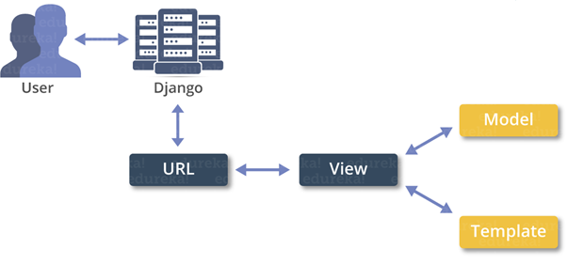

**4.2. INTRODUCTION TO MYSQL**

MySQL (http://www.mysql.com) is a robust SQL database server developed and maintained by T.c.X DataKonsultAB of Stockholm, Sweden. Publically available since 1995, MySQL has risen to become one of the most popular database servers in the world, this popularity due in part to the server’s speed, robustness, and

flexible licensing policy. (See note for more information regarding MySQL’s licensing strategy.)

Given the merits of MySQL’s characteristics, coupled with a vast and extremely easy-to-use set of predefined interfacing functions, MySQL has arguably become PHP’s most-popular database counterpart.

**Installation**

MySQL is so popular among PHP users that support for the db server is automatically built into the PHP distribution. Therefore, the only task that you are left to deal with is the proper installation of the MySQL package. MySQL is compatible with practically every major operating system, including, among others, FreeBSD, Solaris, UNIX, Linux, and the various Windows versions. While the licensing policy is considerably more flexible than that of other database servers, I strongly suggest taking some time to read through the licensing information found at the MySQL site (<http://www.mysql.com>).

You can download the latest version of MySQL from one of the many worldwide mirrors. A complete listing of these mirrors is at http://www.mysql.com/ downloads/mirrors.html. At the time of this writing the latest stable version of MySQL was 3.22.32, with version 3.23 in beta. It is in your best interest to always download the latest stable version. Go to the mirror closest to you and download the version that corresponds with your operating system platform. You’ll see links at the top of the page pointing to the most recent versions. Be sure to read through the entire page, as several OS-specific downloads are at the conclusion. The MySQL development team has done a great job putting together extensive documentation regarding the installation process.

**Configuring MySQL**

After a successful installation, it is time to configure the MySQL server. This process largely consists of creating new databases and configuring the MySQL *privilege* *tables.* The privilege tables control the MySQL database access permissions. Correct configuration of these tables is pivotal to securing your database system, and therefore it is imperative that you fully understand the details of the privilege system before launching your site into a production environment. Although a chore to learn at first, the MySQL privilege tables are extremely easy to maintain once you understand them. A complete introduction to these tables is certainly out of the scope of this book. However, a number of resources available on the Web are geared toward bringing MySQL users up to speed. Check out the MySQL site (http://www.mysql.com) for further information. Once you have correctly installed and configured the MySQL distribution, it’s time to begin experimenting with Web-based databasing! The next section turns our attention towards exactly this matter, starting with an introduction of PHP’s MySQL functionality.

**PHP’s Predefined MySQL Functions**

Once you have created and successfully tested the necessary permissions, you are ready to begin using the MySQL server. In this section, I introduce the predefined MySQL functions, enabling you to easily interface your PHP scripts with a MySQL server. Here is the general order of events that take place during the MySQL server

communications process: 1. Establish a connection with the MySQL server. If the connection attempt fails, display an appropriate message and exit process. 2. Select a database on the MySQL server. If you cannot select the database, display an appropriate message and exit process. It’s possible to simultaneously have several databases open for querying. 3. Perform necessary queries on selected database(s). 4. Once the querying is complete, close the database server connection. The example tables (products, customers, orders) in Figure 11-1 are used as the basis for the examples in the remainder of this section. If you would like to follow along with these examples, I suggest going back and creating them now. Alternatively, make a copy of the pages so you do not have to continuously flip back and forth. With that said, let’s begin at the beginning, that is, how to connect to the MySQL database server.

**mysql_connect()**

The function mysql_connect() is used to establish an initial connection with the MySQL server. Once a successful connection is established, a database residing on that server can be selected.

**The syntax is:**

int mysql_connect([string hostname [:port] [:/path/to/socket] [, string username] [, string password])

The hostname is the name of the host as listed in the MySQL server privilege tables. Of course, it is also used to direct the request to the Web server hosting the MySQL server, since it is possible to connect to a remote MySQL server. An optional *port* number can be included along with the host, in addition to an optional path to a socket when a local host is specified. Both the *username* and *password* input parameters should correspond to the username and password, respectively, as specified in the MySQL server privilege tables. Note that all of the input parameters are optional,

since the privilege tables can be loosely configured to accept a nonauthenticated connection. If the *hostname* parameter is empty, mysql_connect() attempts to connect to the local host.

An example connection call follows: @mysql_connect("localhost", "web", "4tf9zzzf") or die("Could not connect to MySQL server!"); In this case, localhost is the server host, web is the username, and 4tf9zzzf is the password. The @ preceding the mysql_connect() function will suppress any error message that results from a failed attempt, instead producing the custom one specified in the die() call. Note that no value is returned from the mysql_connect() call.

Now, $link1 and $link2 can be called as needed in subsequent queries. You will soon learn exactly how these link IDs are used in queries to specify the

**intended server.**

***mysql_select_db()***

Once a successful connection is established with the MySQL server, a database residing on that server can be selected. This is accomplished with

mysql_select_db().

**NOTE** The function mysql_pconnect() offers persistent connection support. In multiuser environments, mysql_pconnect() is recommended over mysql_connect() as a means for conserving system resources. The mysql_pconnect() input and return parameters are exactly the same as in mysql_connect().

The input parameter database_name should be selected and assigned an identification

handle (returned by mysql_select_db()). Note that the input parameter link_id is optional. This is true only when just a single MySQL server connection is open. When multiple connections are open, link_id must be specified. An example of how a database is selected using mysq(_select_db() follows:

If there is only one database selection, there is no need to return a database ID. However, as with mysql_connect(), when multiple databases are open, the database ID must be returned so there is a way to specify exactly which database you would like to perform a query on; otherwise the most recently *opened* link is used.

**mysql_close()**

Once you have finished querying the MySQL server, you should close the connection. The function mysql_close() will close the connection corresponding to the optional input parameter link_id. If the link_id input parameter is not specified, mysql_close() will close the most recently opened link. The syntax is:

The input parameter query corresponds to an SQL query. This query is sent either to the server connection corresponding to the last opened link or to the connection specified by the optional input parameter link_id. People often mistakenly think that the mysql_query() function returns the results of the query. This is not the case. Depending on the type of query, mysql_query() has different outcomes. In a successful SELECT SQL statement, a result ID is returned that can subsequently be passed to mysql_result() so the selected data can be formatted and displayed to the screen. If the query fails, FALSE is returned. The function mysql_result() is introduced later in this section. Furthermore, the number of rows that have been selected can be determined by executing mysql_num_rows(). This function is also introduced later in this section. In the case of SQL statements involving INSERT, UPDATE, REPLACE, or DELETE, the function mysql_affected_rows() can be called to determine how many rows were affected by the query.

(The function mysql_affected_rows() is introduced next.) With that said, I will delay presenting an example until the mysql_result() and mysql_affected_rows() functions are introduced.

**mysql_pconnect().**

**TIP** If you are concerned that you are using up too much memory when making various query calls, call the predefined PHP function mysql_free_result(). This function, which takes as input the result_id returned from mysql_query(), will free up all memory associated with that query call.

Notice that the input parameter link_id is optional. If it is not included, mysql_affected_rows() attempts to use the last opened link_id. Consider the following

This will not work for queries involving a SELECT statement. To determine the number of rows returned from a SELECT, use the function mysql_num_rows() instead. This function is introduced next.

**mysql_num_rows()**

The function mysql_num_rows() is used to determine the number of rows returned from a SELECT query statement.

its syntax is:

int mysql_num_rows (int result)

A usage example of mysql_num_rows() follows:

**mysql_result()**

The function mysql_result() is used in conjunction with mysql_query() (when a

SELECT query is involved) to produce a data set.

**Its syntax is:**

int mysql_result (int result_id, int row [, mixed field])

The input parameter result_id refers to a value returned by mysql_query().

Following:

* Field offset in the table.
* Field name
* Field name specified in dot format. Dot format is simply another way to specify the field name, specified as fieldname. tablename.

# SYSTEM DESIGN

**5. SYSTEM DESIGN**

**5.1. INPUT DESIGN**

The input design is the link between the information system and the user. It comprises the developing specification and procedures for data preparation and those steps are necessary to put transaction data in to a usable form for processing can be achieved by inspecting the computer to read data from a written or printed document or it can occur by having people keying the data directly into the system. The design of input focuses on controlling the amount of input required, controlling the errors, avoiding delay, avoiding extra steps and keeping the process simple. The input is designed in such a way so that it provides security and ease of use with retaining the privacy. Input Design considered the following things:

* What data should be given as input?
* How the data should be arranged or coded?
* The dialog to guide the operating personnel in providing input.
* Methods for preparing input validations and steps to follow when error occur.

**OBJECTIVES**

1. Input Design is the process of converting a user-oriented description of the input into a computer-based system. This design is important to avoid errors in the data input process and show the correct direction to the management for getting correct information from the computerized system.
2. It is achieved by creating user-friendly screens for the data entry to handle large volume of data. The goal of designing input is to make data entry easier and to be free from errors. The data entry screen is designed in such a way that all the data manipulates can be performed. It also provides record viewing facilities.
3. When the data is entered it will check for its validity. Data can be entered with the help of screens. Appropriate messages are provided as when needed so that the user will not be in maize of instant. Thus the objective of input design is to create an input layout that is easy to follow

**5.2. OUTPUT DESIGN**

A quality output is one, which meets the requirements of the end user and presents the information clearly. In any system results of processing are communicated to the users and to other system through outputs. In output design it is determined how the information is to be displaced for immediate need and also the hard copy output. It is the most important and direct source information to the user. Efficient and intelligent output design improves the system’s relationship to help user decision-making.

1. Designing computer output should proceed in an organized, well thought out manner; the right output must be developed while ensuring that each output element is designed so that people will find the system can use easily and effectively. When analysis design computer output, they should Identify the specific output that is needed to meet the requirements.
2. Select methods for presenting information.
3. Create document, report, or other formats that contain information produced by the system.

The output form of an information system should accomplish one or more of the following objectives.

* Convey information about past activities, current status or projections of the
* Future.
* Signal important events, opportunities, problems, or warnings.
* Trigger an action.
* Confirm an action.

**5.3. DATABASE DESIGN**

**Management_PlacementModel**

|  |  |
| --- | --- |
| **FIELD NAME** | **DATA TYPE** |
| Id | Int |
| Batch | Varchar(300) |
| AppNo | Varchar(200) |
| PlaceNo | Varchar(200) |
| Min | Varchar(200) |
| Max | Varchar(200) |
| Avg | Varchar(200) |
| Rate | Varchar(200) |

**Management_RegisterModel**

|  |  |
| --- | --- |
| **FIELD NAME** | **DATA TYPE** |
| Id | Int |
| FirstName | Varchar(3000 |
| LastName | Varchar(200) |
| UserId | Varchar(200)) |
| Password | Varchar(200) |
| MbleNum | Varchar(200) |
| Email | Varchar(200) |
| Gender | Varchar(10) |

**Management_StudentModel**

|  |  |
| --- | --- |
| **FIELD NAME** | **DATA TYPE** |
| Id | Int |
| Batch | Varchar(3000 |
| RollNo | Varchar(200) |
| Company | Varchar(200)) |
| Name | Varchar(200) |
| University | Varchar(200) |
| Department | Varchar(200) |
| SslcPer | Varchar(100) |
| HscPer | Varchar(100) |
| CGPA | Varchar(100) |

# SYSTEM ARCHITECTURE

# 6. SYSTEM ARCHITECTURE

**6.1. SYSTEM ARCHITECTURE**

A system architecture or systems architecture is the computational design that defines the structure and/or behavior of a system.

An architecture description is a formal description of a system, organized in a way that supports reasoning about the structural properties of the system. It defines the system components or building blocks and provides a plan from which products can be procured, and systems developed , that will work together to implement the overall system.



**6.2. DATA FLOW DIAGRAM**

User

True

False

Data Collection

Collect the data set

Gather and store placement details

Placement details

Generate graphical analysis

Graphical Analysis

Chat with bot regard placement

Chat Bot

**6.3. UML DIAGRAM**

**6.3.1. USE CASE DIAGRAM**

Data Collection

Placement Details

Graphical Analysis

Chat Bot

Logout

User

**6.3.2. SEQUENCE DIAGRAM**

User

Data Collection

Placement Details Shipper

Collect Data Set

Store & analyze placement details

Graphic Analysis

View Analyze Report as chart

Chat Bot

Chat with bot placement regards

**6.3.3. ACTIVITY DIAGRAM**

User Login

Data Collection

Placement Details

Graphical Analysis

Chat Bot

**6.3.4. CLASS DIAGRAM**

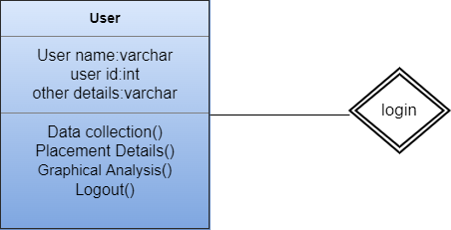

# SYSTEM IMPLEMENTATION

**7. SYSTEM IMPLEMENTATION**

Implementation is the stage in the project where the theoretical design is turned into a working system. The most critical stage is achieving a successful system and in giving confidence on the new system for the users, what it will work efficient and effectively. It involves careful planning, investing of the current system, and its constraints on implementation, design of methods to achieve the change over methods.

The implementation process begins with preparing a plan for the implementation of the system. According to this plan, the activities are to be carried out in these plans; discussion has been made regarding the equipment, resources and how to test activities.

The coding step translates a detail design representation into a programming language realization. Programming languages are vehicles for communication between human and computers programming language characteristics and coding style can profoundly affect software quality and maintainability. The coding is done with the following characteristics in mind.

* Ease of design to code translation.
* Code efficiency.
* Memory efficiency.
* Maintainability.

The user should be very careful while implementing a project to ensure what they have planned is properly implemented. The user should not change the purpose of project while implementing. The user should not go in a roundabout way to achieve a solution; it should be direct, crisp and clear and up to the point.

Implementation is the stage of the project when the theoretical design is turned out into a working system. Thus it can be considered to be the most critical stage in achieving a successful new system and in giving the user, confidence that the new system will work and be effective.

The implementation stage involves careful planning, investigation of the existing system and it’s constraints on implementation, designing of methods to achieve changeover and evaluation of changeover methods.

**MODULES:**

**1. Multiple regression analysis**

A multiple regression analysis determines the relationship between variables such as the dependent variable and other independent variables. In particular, multiple regression analysis aims to understand changes in dependent variable y through movements in k (independent) explanatory variables xl, x2, ………, xk. The general form of the multiple regression analysis is expressed in the following way: where βk are parameters, xik are known constants, ∈i is the residual, and n is equal to the number of predictors. The RMSE, MSE, MAE, and R2 statistics for the developed multiple regression model were provided respectively, and model outputs have demonstrated that the real values are closely followed.

**2. Ridge regression**

Ridge regression is a conventional linear regression, using an error function and a regularization technique in the sum of squares to monitor the bias variance interchange, with the goal of detecting the linear structures embedded in the data.

**3. Least absolute shrinkage and selection operator (LASSO) regression**

The LASSO regression is presented by Tibshirani (1996), and it is a modification of linear regression. Similar to ridge regression, LASSO regression model penalizes the magnitude of coefficients to avoid overfitting (Vrontos et al., 2021; Qin et al., 2018).

**4. Elastic net regression**

The elastic-net algorithm linearly combines the penalties of the ridge and lasso methods (Richardson et al., 2021; Zou & Hastie, 2005). The elastic-net algorithm performs a fading between the lasso and ridge algorithms through a parameter 0 ≤ α ≤ 1. For α = 1; the elastic-net is equal to the lasso algorithm, and for α = 0 it is equal to the ridge algorithm. It is a compromise between the two approaches when 0 < α < 1. Thus, elastic-net algorithm generalizes the ridge and lasso methods. Based on the results obtained, the RMSE, MSE, MAE, and R2 values for the developed elastic-net regression model were noted to be 9.64, 93.08, 6.33, and 0.916, respectively.

# SYSTEM TESTING

**8. SYSTEM TESTING**

System Testing is an important stage in any system development life cycle. Testing is a process of executing a program with the intention of finding errors. The importance of software testing and its implications with respect to software quality cannot be overemphasized. Software testing is a critical element of software quality assurance and represents the ultimate review of specification, design and coding. A good test case is one that has a high probability of finding a yet undiscovered error.

The purpose of testing is to discover errors. Testing is the process of trying to discover every conceivable fault or weakness in a work product. It provides a way to check the functionality of components, sub assemblies, assemblies and/or a finished product It is the process of exercising software with the intent of ensuring that the Software system meets its requirements and user expectations and does not fail in an unacceptable manner. There are various types of test. Each test type addresses a specific testing requirement.

Testing is the set of activities that can be planned in advance and conducted systematically. Different test conditions should be thoroughly checked and the bugs detected should be fixed. The testing strategies formed by the user are performed to prove that the software is free and clear from errors. To do this, there are many ways of testing the system’s reliability, completeness and maintainability.

The important phase of software development is concerned with translating the design specification into the error-free source code. Testing is carried out to ensure that the system does not fail, that it meets the specification and it satisfies the user. The system testing was carried out in a systematic manner with a test data containing all possible combinations of data to check the features of the system. A test data was prepared for each module, which took care of all the modules of the program.

System Testing is an important stage where the system developed is tested with duplicate or original data. It is a process of executing a program with the intent of finding an error. It is a critical process that can consume fifty percent of the development time.

The following are the attributes of good test:

* A good test is not redundant.
* A good test should be "best of breed".
* A good test should be neither simple nor too complex.

**8.1. UNIT TESTING**

In the unit testing the analyst tests the program making up a system. The software units in a system are the modules and routines that are assembled and integrated to perform a specific function. In a large system, many modules on different levels are needed.

Unit testing can be performed from the bottom up starting with the smallest and lowest level modules and proceeding one at a time. For each module in a bottom-up testing, a short program executes the module and provides the needed data.

# 8.2. INTEGRATION TESTING

Integration testing is a systematic technique for constructing the program structure while conducting test to uncover errors associate with interfacing. Objectives are used to take unit test modules and built program structure that has been directed by design.

The integration testing is performed for this Project when all the modules where to make it a complete system. After integration the project works successfully.

# 8.3. VALIDATION TESTING

Validation testing can be defined in many ways, but a simple definition is that can be reasonably expected by the customer. After validation test has been conducted, one of two possible conditions exists.

* The functions or performance characteristics confirm to specification and are accepted.
* A deviation from specification is uncovered and a deficiency list is created.

Proposed system under consideration has been tested by using validation testing and found to be working satisfactorily.

For example, in this project validation testing is performed against module. This module is tested with the following valid and invalid inputs for the field id.

##### 8.4. WHITE BOX TESTING

White box testing, sometimes called glass-box testing is a test case design method that uses the control structure of the procedural design to derive test cases. Using white box testing methods, the software engineer can derive test cases that

* Guarantee that all independent paths with in a module have been exercised at least once.
* Exercise all logical decisions on their true and false sides.
* Execute all loops at their boundaries and with in their operational bounds and
* Exercise internal data structure to assure their validity.

For example in this project white box testing is performed against patient module. Without entering text if we apply it displays the message “First add record then save it” else it should be saved.

##### 8.5. BLACK BOX TESTING

This method treats the coded module as a black box. The module runs with inputs that are likely to cause errors. Then the output is checked to see if any error occurred. This method cannot be used to test all errors, because some errors may depend on the code or algorithm used to implement the module.

# CONCLUSION

**9. CONCLUSION**

The main aim of this study was to develop machine learning algorithms for predicting the percentage of student placement based on the data related to the university’s academic reputation, opportunities of the city where the university is located, facilities and cultural opportunities of the university. The estimated output values generated by extreme gradient boosting were found to be the most satisfactory when the performance values were calculated. The three most sensitive factors that contributed over 85% of the sensitive weights together represented the percentage of student placement in year t-1, the university scientific document score, and university Phd programme score. Prediction results obtained in this study can be used in many different ways, such as determining the quotas for universities, allocating resources, regulating university enrollments, and making new regulations. In order to make the universities more effective and productive, The Council of Higher Education in Turkey regulates university enrollments. Thus, the results obtained from this study helps The Council of Higher Education to find out the required quotas that the universities need. The reliability of machine learning algorithms depends mainly on its ability to learn from the previous data.

**FUTURE ENHANCEMENT**

In future, we can include additional experiments with more primal machine learning algorithm. We can obtain more training records by including other engineering departments or majors to generalize the model, and boost the performance of machine learning algorithms.

**APPENDIX**

**APPENDIX -1.1**

**SCREENSHOTS**

**Run the Project:**

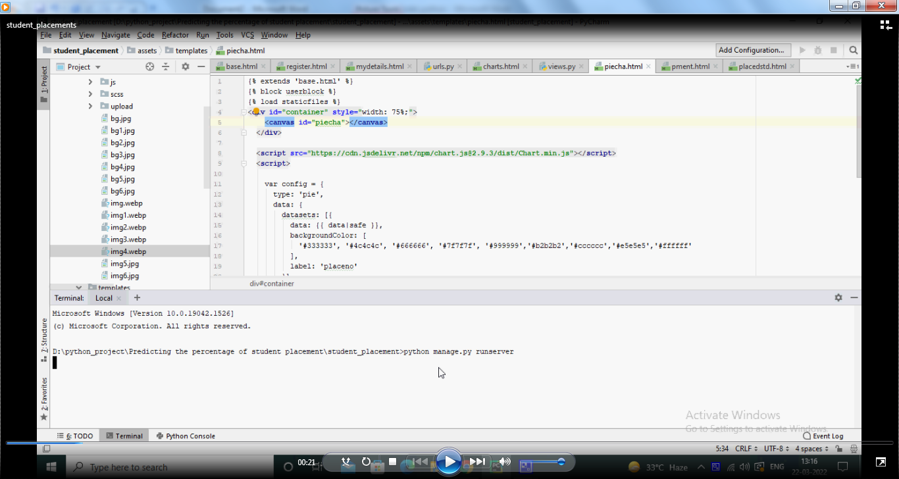

**Server started:**

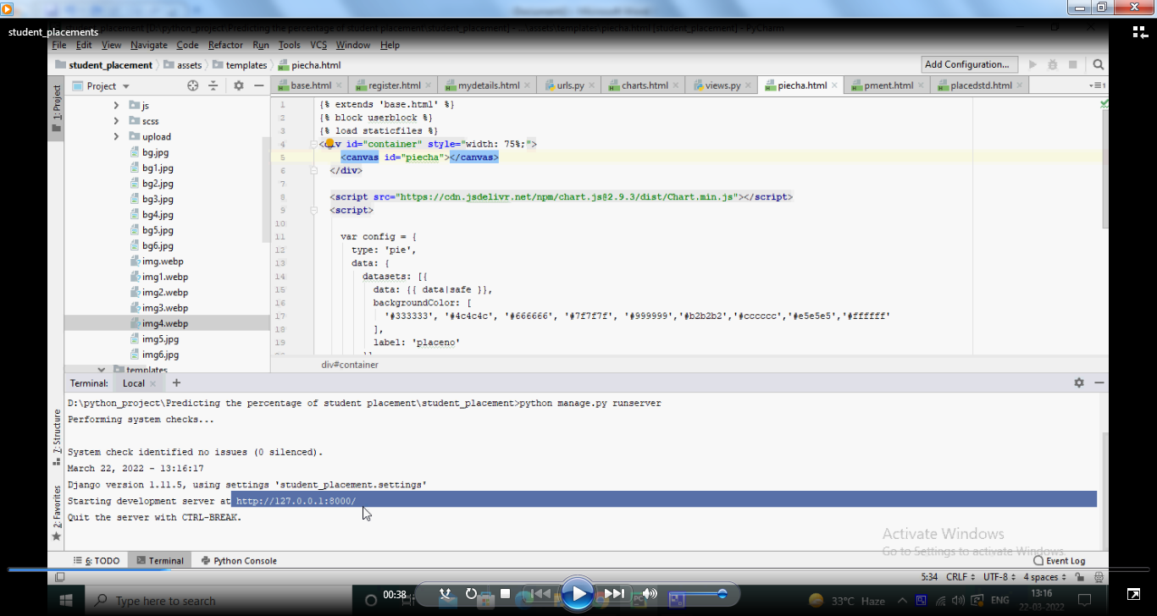

**User login:**

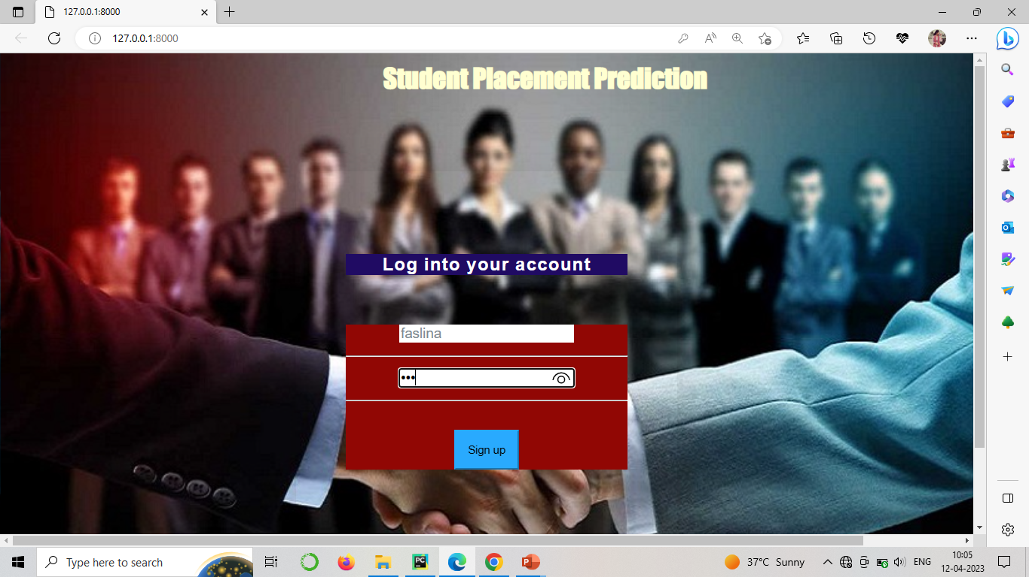

**User Registration :**

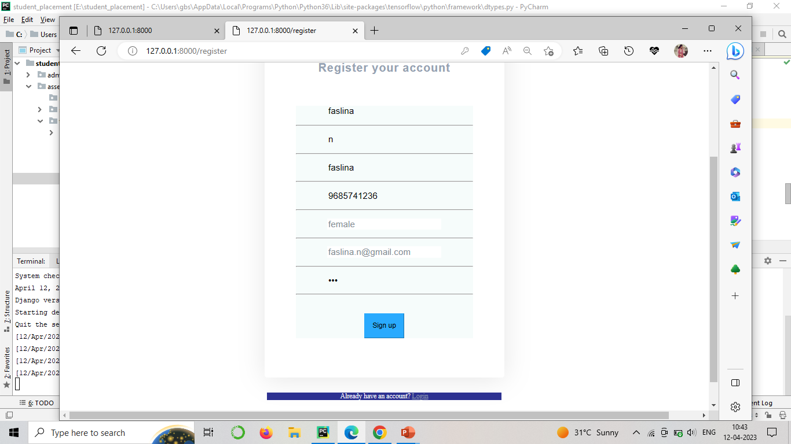

**Student Details:**

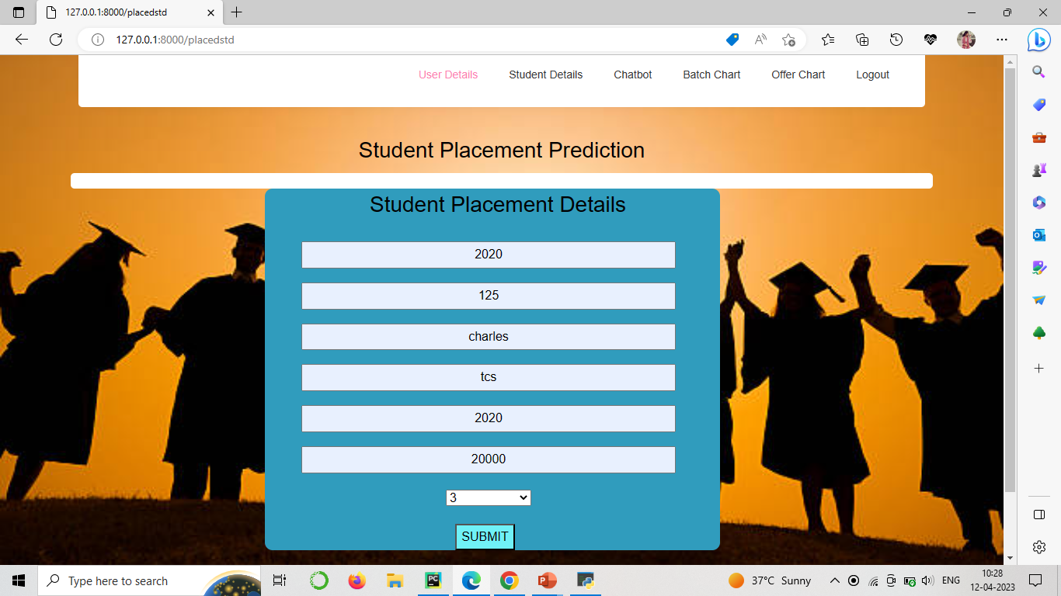

**Prediction based on batch:**

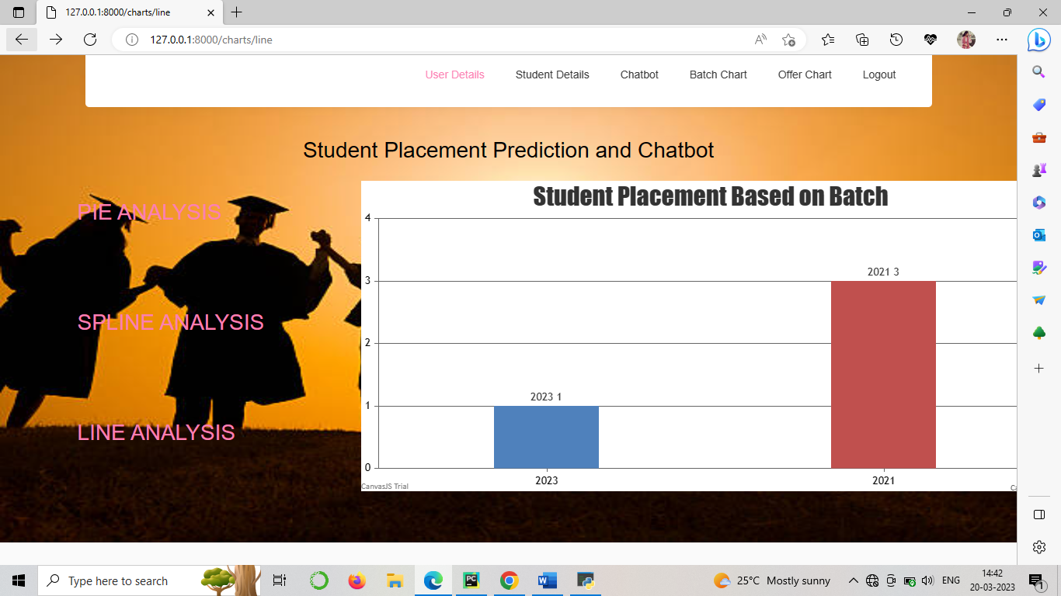

**Prediction based on offers:**

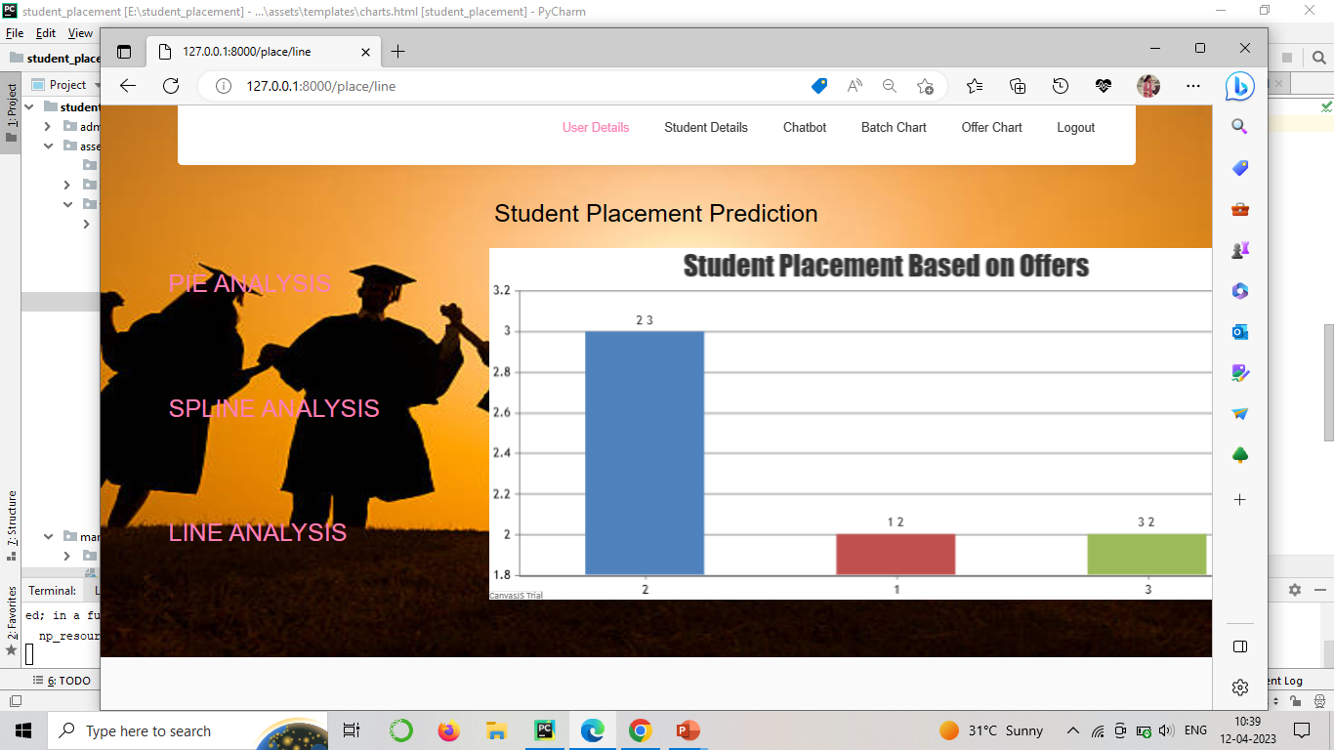

**Admin Login:**

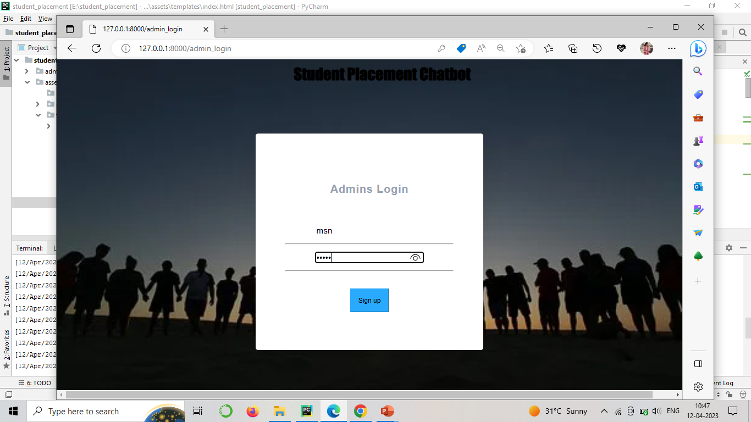

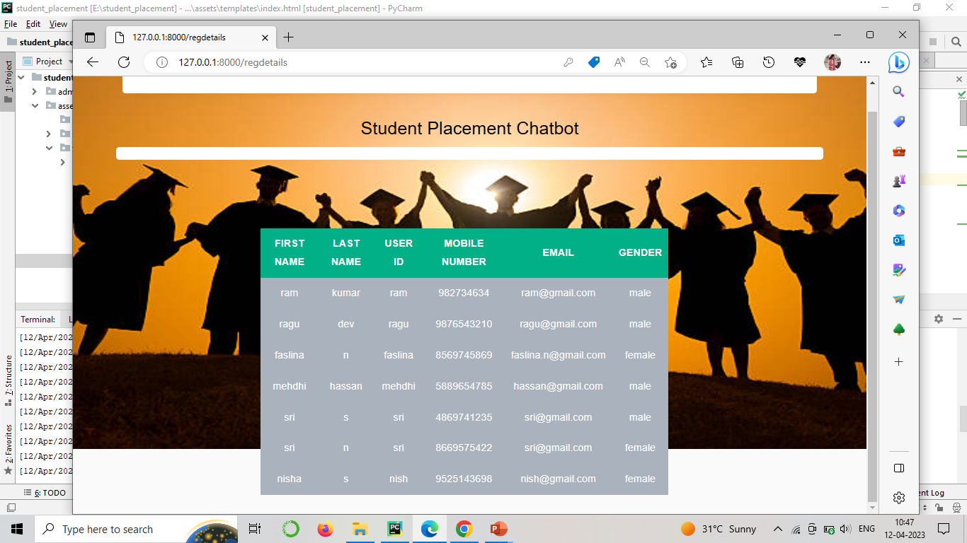

**APPENDIX -1.2**

**CODING**

**Views.py**

from django.db.models import Count

from django.http import HttpResponse

from django.shortcuts import render, redirect, get_object_or_404

# Create your views here.

from management.models import RegisterModel, placementModel, StudentModel

def index(request):

if request.method == "POST":

name = request.POST.get('userid')

password = request.POST.get('password')

try:

enter = RegisterModel.objects.get(userid=name,password=password)

request.session["names"]= enter.id

return redirect('mydetails')

except:

pass

return render(request, 'index.html')

def register(request):

if request.method == "POST":

userid= request.POST.get('userid')

firstname = request.POST.get('firstname')

lastname = request.POST.get('lastname')

password = request.POST.get('password')

email = request.POST.get('email')

mblenum = request.POST.get('mblenum')

gender = request.POST.get('gender')

RegisterModel.objects.create(userid=userid,firstname=firstname,lastname=lastname,password=password,email=email,

mblenum=mblenum,gender=gender)

return render(request, 'register.html')

def pment(request):

if request.method == "POST":

appno= request.POST.get('appno')

placeno = request.POST.get('placeno')

min = request.POST.get('min')+'L'

max = request.POST.get('max')+'L'

avg = request.POST.get('avg')+'L'

batch = request.POST.get('batch')

po = int(placeno)

app = int(appno)

rate =((po/app)*100)

if placementModel.objects.filter(batch=batch).exists():

return HttpResponse("Batch Already Taken")

placementModel.objects.create(appno=appno,placeno=placeno,min=min,max=max,avg=avg,

batch=batch,rate=rate)

return render(request, 'pment.html')

def placedstd(request):

if request.method == "POST":

ba= request.POST.get('ba')

rollno = request.POST.get('rollno')

company = request.POST.get('company')

name = request.POST.get('name')

university = request.POST.get('university')

department = request.POST.get('department')

sslcper = request.POST.get('sslcper')+'%'

hscper = request.POST.get('hscper') +'%'

cgpa = request.POST.get('cgpa')+'%'

gymObj = placementModel.objects.get(batch=ba)

dd = gymObj.id

placeno = gymObj.placeno

appno = gymObj.appno

val = gymObj.placeno

if placementModel.objects.filter(batch=ba).exists():

obj = get_object_or_404(placementModel,id=dd)

obj.placeno = (int(val) + 1)

po = int(placeno)

app = int(appno)

obj.rate = ((po / app) * 100)

obj.save(update_fields=["placeno","rate"])

StudentModel.objects.create(ba=ba,rollno=rollno,company=company,name=name,university=university,

department=department,sslcper=sslcper,hscper=hscper,cgpa=cgpa)

return render(request, 'placedstd.html')

def mydetails(request):

names = request.session['names']

ted = RegisterModel.objects.get(id=names)

return render(request, 'mydetails.html',{'obje':ted})

def charts(request):

labels = []

data = []

queryset = placementModel.objects.order_by('-placeno')[:8]

for city in queryset:

labels.append(city.batch)

data.append(city.placeno)

return render(request,'charts.html',{'labels': labels, 'data': data,})

def piecha(request):

labels = []

data = []

queryset = placementModel.objects.order_by('-placeno')[:9]

for city in queryset:

labels.append(city.batch)

data.append(city.placeno)

return render(request,'piecha.html',{'labels': labels, 'data': data,})

**REFERENCE**

**REFERENCE**

Good Teachers are worth more than thousand books, we have them in Our Department

**References Made From:**

[1] Shreyas Harinath, Aksha Prasad, Suma H and Suraksha A. Student Placement Prediction using Machine Learning, International Research Journal of Engineering and Technology (IRJIET) Volume : 06 Issue: 04 April 2019.

[2] K. Sreenivasa Rao, N. Swapna, P. Praveen Kumar Educational data mining for student placement prediction using machine Learning algorithms Research Paper, International Research Journal of Engineering and Technology (IRJIET) 2018.

[3] I. Κ., Fitsilis, P., & Gerogiannis, V. C. (2021). A two-phase machine learning approach for predicting student outcomes. Education and Information Technologies, 26(1), 69–88.

[4] Hao, J., & Ho, T. K. (2019). Machine learning made easy: A review of scikit-learn package in python programming language. Journal of Educational and Behavioral Statistics, 44(3), 348–361.

[5] Swamynathan, M. (2019). Mastering machine learning with python in six steps: A practical implementation guide to predictive data analytics using python.

**Sites Referred:**

http://www.sourcefordgde.com

http://www.networkcomputing.com/

http://www.ieee.org

http://www.almaden.ibm.com/software/quest/Resources/